Xidian University & Heriot-Watt University

**Semiconductor Bandgap**

(Lab 1)

Semiconductor Electronics

Xunchi Ma

21012100092

2023-11-08

**1.Aims and Objectives**

The objective of this experiment is to utilize the principles of semiconductor theory to approximate the energy band gap based on leakage current measurements in a silicon diode across varying temperatures. A significant portion of the experiment involves the manipulation of intricate equations to produce graphical data, which can then be readily compared to theoretical predictions.

1. **Background Theory**

Through the calculation

$$\frac{d(ln I_{R})}{d(\frac{1}{T})}=−\frac{3}{2}T−\frac{E_{g0}}{2k}（1）$$

The silicon's reverse leakage current will fluctuate in accordance with the equation (1) above. By measuring this current across different temperatures and graphing the outcomes, an estimated value for the semiconductor material's energy gap can be determined.

**3.Experimental Equipment**

Temperature controlled heating block with silicon power diode type RUR860

attached.

Siglent SPD3303X-E Programmable DC Power Supply (2 channels)

Siglent SDM3065X Digital Multimeter.

Junction box with 1 kΩ resistor.

**4.Experimental Procedure**

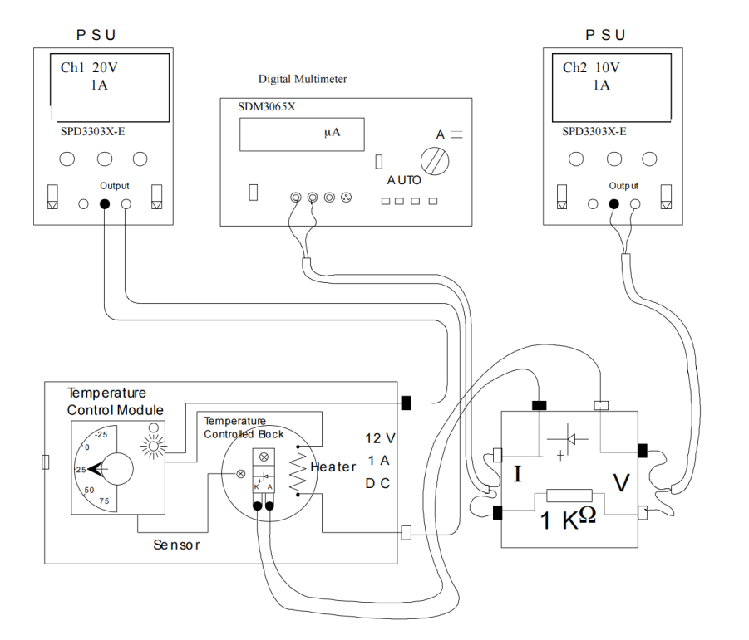

Figure 1: Experimental Equipment

Assemble the equipment as indicated in Figure 1, making certain that the RS temperature controller is set to zero. Utilize the green and yellow buttons to select the appropriate channels on the power supply. Configure Channel 1 to 20 volts for the temperature control box's power supply. For the power supply connected to the junction box, which is used to reverse bias the diode, set Channel 2 to 10 volts. Activate the digital multimeter's auto-ranging DC current measurement mode by pressing 'Shift' followed by 'DCV'. The initial current reading at room temperature will likely fall within the range of 10 to 100 nA.

Increment the block temperature in steps of 10 degrees, allowing ample time for thermal stabilization, which is indicated by the green LED turning off or flashing. This may require a minimum of 10 minutes; closely observe the green LED and take the current measurement immediately once stabilization occurs. Document your findings in a table.

During each 10-degree temperature increase, record the current value displayed on the multimeter. Continue this process until you reach a temperature of 150°C, starting from 50°C. Upon completion of the experiment, make sure to turn off all the equipment.

**5.Results**

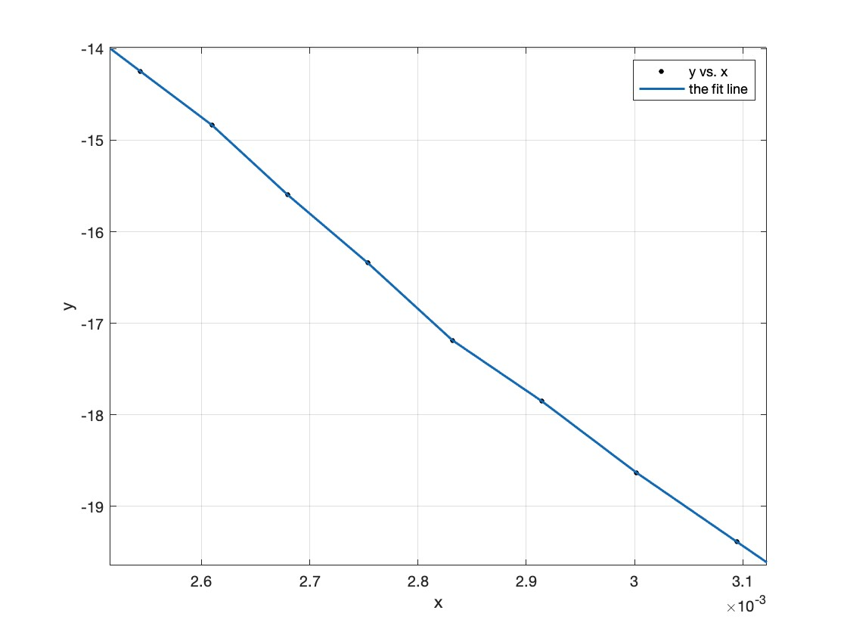

Figure 2: the ln(IR)(y) and 1/T(x) chart

after calculate its slope which is -8928.499, and using the equation (1), take the average temperature which is 338K

$$−8928.499=−\frac{3}{2}×338−\frac{E_{g0}}{2k}$$

where k is equal to 1.38 x 10-23 J.K^-1

and then Eg0 can be calculated and its value is 2.324*10^-19 J,or 1.4527 eV.

1. **Analysis and Discussion of Results**

Q:Comment on the accuracy of the results you have obtained for the value of the energy

band gap

A:According to the result the energy gap is 1.45eV which have a 29% error with respect to the energy gap of Si (1.12eV). So the accuracy of this experiment is not so high. The error was mainly caused by the accuracy of thermometer, whose smallest step is 5 degrees.

Q:four types of diodes and their uses.

A:

·Rectifier Diodes

Uses:

Power Supply Conversion: They are commonly used to convert alternating current (AC) to direct current (DC) in power supplies.

Voltage Clipping: To limit the output voltage to a certain level.

· Zener Diodes

Uses:

Voltage Regulation:Zener diodes are frequently used as voltage regulators to provide a constant voltage to a load.

Signal Clipping: They can be used to clip signals to prevent voltage levels from exceeding a set limit.

·Light-Emitting Diodes (LEDs)

Uses:

Indicators and Displays: LEDs are used in a wide range of applications like display screens, indicators, and lighting.

Optical Communication: They are also used in optical fiber communication systems for short-range applications.

·Schottky Diodes

Uses:

Switching Applications: Due to their fast switching speeds, they are often used in high-frequency circuits.

Voltage Drop: They have a lower forward voltage drop compared to standard diodes, making them more efficient in certain applications like DC-DC converters.

Q:Comment on how you would expect the energy band diagram of the diode to change

with temperature. Describe what happens in the semiconductor so that the leakage

current increases.

A:as temperature increases, the energy band diagram of a diode will show a narrowing band gap, a shift in the Fermi level, and increased carrier concentrations. These changes lead to a higher leakage current primarily due to the increased number of thermally generated charge carriers that can cross the junction, even in the absence of an external voltage.

**7.References**

Solid State Electronic Devices by B. G. Streetman & S. Banerjee, 5th edition, Prentice

Hall, 2000. Understanding Semiconductor Devices by S. Dimitrijev, Oxford

University Press, 2000. Introduction to Semiconductor Materials and Devices by M.

S. Tyagi, 1991, Wiley